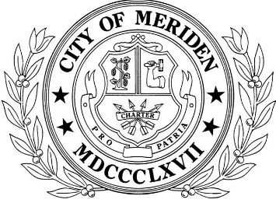
City of Meriden - Meriden Senior Center

Part Time Mini-Bus Driver
19.75 hours per week

The City of Meriden is hiring a part-time (19.75 hours per week) Mini-Bus Driver to work in the Senior Center transportation program. The Senior Center is open Monday through Friday, 8:30am to 4:00pm.

The Mini-Bus Driver is responsible for transporting senior citizens via mini-bus for shopping and medical appointments. Duties include driving, cleaning and routine maintenance on a mini-bus. Candidates must have a valid State of Connecticut driver’s license, with a CDL, and a passenger endorsement. Knowledge of Meriden streets a plus. Exemplary driving record is necessary.

The hourly salary is $17.13 per hour.

This position will work 3 days per week:
Monday 8:00am to 4:00pm – w/ half hour lunch
Wednesday 8:00am to 4:00pm – w/ half hour lunch
Thursday 8:00am to 12:45pm 4.75 hours

Apply on line at https://tinyurl.com/meridencareers and e-mail your resumes/applications to humanresources@meridenct.gov. Applications are also available in the Human Resources Department, City Hall, 142 East Main Street. Please call to make an appointment. Monday – Friday, 8:00am – 5:00 pm 203.630.4037.

Open until filled

E.O.E

