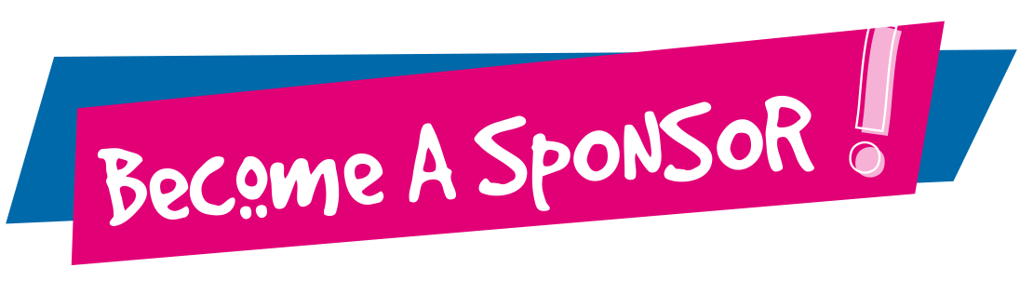
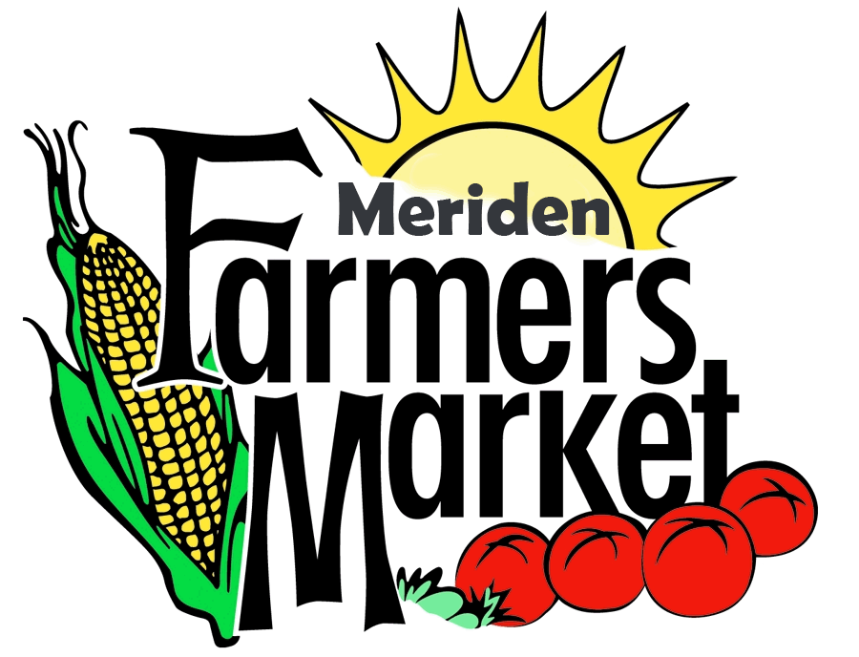

Premiere  $1000+ | Gold  $500 | Silver  $250
- Acknowledgement on the Meriden Farmers’ Market  booth banner | - Acknowledgement on the Meriden Farmers’ Market booth banner | - Recognition on the Meriden Farmers’ Market website
- Recognition on the Meriden Farmers’ Market website |   - Recognition on the Meriden Farmers’ Market website
- Prominent display on the Meriden Farmers’ Market entrance sign
- Recognition on city roadside displays around Meriden
- A booth any week of your choosing identifying you as a Premiere Sponsor

---------------------------------------------------------------------------------------

Meriden Farmers Market
Sponsorship Form

Sponsor Name (Company/Organization) ___________________________________________
Company Address _____________________________________________________________
Contact Person ___________________________ Phone number _______________________
Sponsor Level ___________________________ Amount $ ___________________________

Make checks payable to: Meriden Farmers Market

Mail to: Meriden Farmers Market
200 Research Parkway
Meriden, CT 06450

Contact: (203) 494-3712

