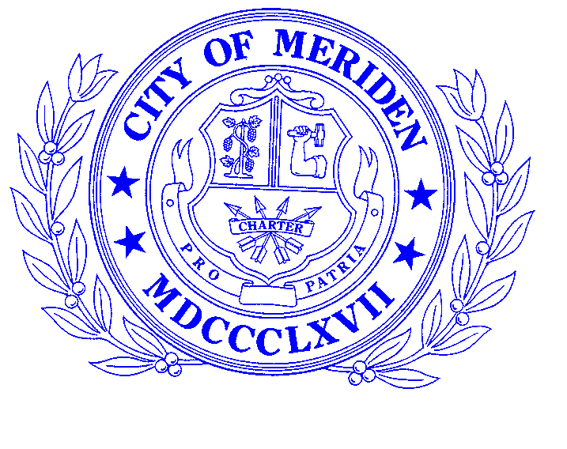
2
City of Meriden, Connecticut
OFFICE OF THE CITY MANAGER
142 East Main Street, City Hall
Meriden, CT 06450-5605
Telephone (203) 630-4123 • Fax (203) 630-4274
tcoon@meridenct.gov

Timothy P. Coon
City Manager

CITY BUILDING MASK STATUS
15 June 2021
Due to the on-going emergency around the spread of the corona virus, the following policy for the City of Meriden is currently in force:
1. All members of the public are required to wear masks while conducting business in City buildings.
2. This policy will be in effect until vaccination rates reach a higher level (to be determined) than the current 45% as of 9 June 2021.
3. All departments and City buildings are currently open to the public.
4. The public is requested to utilize on-line payments and mail-in payments to the greatest extent possible. Specific questions concerning services may be answered by calling, or emailing the respective department that members of the public are intending to visit. Phone numbers and emails for departments are located on their web pages on the City website.
5. This policy may be subject to change as the situation warrants.
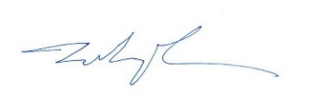

Timothy Coon
City Manager
City of Meriden

