January 20, 2021

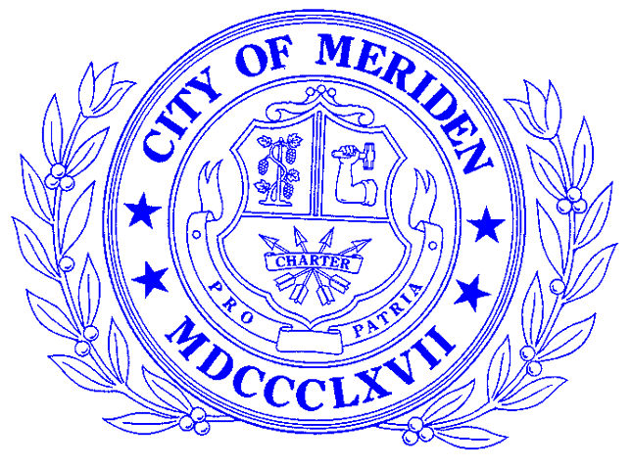

PRESS RELEASE – FOR IMMEDIATE RELEASE

Mayor Garcetti announces major steps to promote racial equity in Los Angeles
Francis T. Maloney Scholarship for 2021 is Now Available
MERIDEN- Applications for the Francis T. Maloney Scholarship for 2021 are available at Maloney High, Platt High, and Wilcox Technical High School and the City of Meriden website according to Denise L. Grandy, Chair of the Maloney Scholarship Committee.
Students attending out of town schools but residents of Meriden may obtain applications from the above schools or from the City Clerk's Office at 203-630-4030.
The award is made by the City of Meriden in memory of the late U.S. Senator Francis T. Maloney. The Scholarship is made on a continuing basis for four years based on satisfactory work during college enrollment.
Applicants must possess outstanding character, excellent academics, well-rounded personality and leadership ability. They must also have been a resident of Meriden for at least four years.
-30-
Belen Michelis, Strategic Communications Specialist, bmichelis@meridenct.gov, 203-535-5663

